


Í

Louisiana State University
Industrial Training & Assessment Center

Energy, Waste, and Productivity Assistance for Industry
A U.S. Department of Energy Sponsored Program

Assessment Report

Report No.: LS2503
Location: Houma, LA
Principal Products: Ship Building
SIC Number: 3731

Dr. Jonathan Shi – Director | Asif Chowdhury– Student Lead
Dr. Chao Wang – Assistant Director | Sueed Willoughby – Safety/Equipment Lead
Ms. Chandler Hayes – Assistant Director | Nicholas Wagner – Student Engineer
Oliver Kraklow – Student Engineer
Colleen Angelle – Student Engineer
Tommy Nguyen – Student Engineer

Louisiana State University - Industrial Training & Assessment Center (LSU-ITAC)
College of Engineering
3319 Patrick F. Taylor Hall, Baton Rouge, LA
Phone: (225) 578-8652
PREFACE

The work described in this report was performed by the Louisiana State University-Industrial Training & Assessment Center (LSU-ITAC) at the Louisiana State University under contract with the Office of Manufacturing and Energy Supply Chains (MESC) of the U.S. Department of Energy. The ITAC program is managed by the Center for Advanced Energy Systems, Rutgers University, Piscataway, NJ, under contract with the U.S. Department of Energy.

The objective of the ITAC program is to identify and evaluate opportunities for energy efficiency improvements through visits to industrial facilities. The evaluation process is based on the data gathered during a one-day site visit and is thereby affected in detail and completeness by limitations on time at the site. In cases where assessment recommendations (ARs) involving engineering design and capital investment are attractive to the company, it is recommended that the services of a consulting engineering firm be engaged (when in-house expertise is not available) to do detailed engineering design and to estimate implementation costs. Comments regarding this assessment report and information about plans to implement the ARs identified are solicited.

In this assessment, the students observed, took notes, asked questions, and helped develop the ARs that were recommended in this report. Asif Faisal Chowdhury was the Student Lead, Sueed Willoughby was the Safety/Equipment Lead, and Nicholas Wagner, Oliver Kraklow, Colleen Angelle, and Tommy Nguyen were the Student Engineers.

DISCLAIMER

The contents of this report are offered as guidance. Rutgers University (the State University of New Jersey), Louisiana State University, and all technical sources referenced in the report do not (a) make any warranty (expressed or implied) with respect to the accuracy, completeness, or usefulness of the information contained in this report; (b) represent that the use of any information, apparatus, method, or process disclosed in this report will not infringe on privately owned rights; or (c) assume any liabilities with respect to the use of, or for damages resulting from the use of, any information, apparatus, method, or process disclosed in this report. This report does not reflect official views or policies of the abovementioned institutions. Mention of trade names or commercial products does not constitute endorsement or recommendation of use.

Table of Contents

1 EXECUTIVE SUMMARY 6
1.1 General Information 6
1.2 Annual Energy Usages and Costs 6
1.3 Carbon Footprint 6
1.4 Summary of Best Practices and Assessment Recommendations 6
2 GENERAL FACILITY BACKGROUND 9
2.1 Facility Description 9
2.2 Process Description 9
2.3 Historical Energy Usage 10
2.4 Major Energy Consuming Equipment and Devices 12
3 CURRENT BEST PRACTICES 14
3.1 Partial Implementation of LED Retrofits in Facility 14
3.2 Recycling of Metal 14
3.3 Use of Robotic Welding System 15
3.4 Use of Skylights 15
4 ASSESSMENT RECOMMENDATIONS (ARS) 16
4.1 AR No. 1 – Install Programmable Thermostat in the Office 16
4.2 AR No. 2 – Utilize Daylight Whenever Possible in Lieu of Artificial Light 21
4.3 AR No. 3 – Utilize Higher Efficiency Lamps and/or Ballasts 26
4.4 AR No. 4 – Upgrade Controls on Air Compressor System 32
5 INDUSTRIAL CONTROL SYSTEMS CYBERSECURITY ASSESSMENT 37

Table of Figures

Figure ‎2-1. The Satellite View of the Facility 9
Figure ‎2-2. The Production Process Flowchart 10
Figure ‎2-3. Monthly Electricity Cost 11
Figure ‎2-4. Monthly Electricity Usage 11
Figure ‎2-5. Monthly Demand Charge 12
Figure ‎2-6. Monthly Demand Usage 12
Figure ‎2-7. The Major Power Consumers 13
Figure ‎3-1. LED Retrofits in the Facility. 14
Figure ‎3-2. Recycling Metals 14
Figure ‎4-1. The Types of Programmable Thermostats. 16
Figure ‎4-2. The Cooling Hour Count for the Cooling Unit Set at 72°F 17
Figure ‎4-3. The Cooling Hours Count Based on 72 – 80°F in a Proposed Schedule 18
Figure ‎4-4. Daylight Sensor and Photocell Sensor 21
Figure ‎4-5. Metal Halide Bulbs in Facility 26
Figure ‎4-6. Recommended LED Lighting Types 30
Figure ‎4-7. Air Compressor Specification 32
Figure ‎4-8. Optimizer and Master Controller for Air Compressor System 33

List of Tables

Table ‎1-1. The Facility Energy and Material Usage Summary 6
Table ‎1-2. The Carbon Footprint of the Facility 6
Table ‎1-3. The Assessment Recommendation Summary Table 8
Table ‎2-1. The Operating Hours and Shift Schedule 9
Table ‎2-2. The Major Power Consuming Equipment 13
Table ‎4-1. The Savings Summary for AR No. 1 16
Table ‎4-2. The Recommended Settings for Cooling Setpoints 18
Table ‎4-3. The Implementation Cost Summary for AR No. 1 20
Table ‎4-4. The Savings Summary for AR No. 2 21
Table ‎4-5. The Summary of Lighting Equipment for Sensor Installation 22
Table ‎4-6. The Implementation Cost Summary for AR No. 2 25
Table ‎4-7. The Savings Summary for AR No. 3 26
Table ‎4-8. The Summary of Existing Lighting Equipment in the Facility 26
Table ‎4-9. The Summary of Recommended Lighting Equipment in the Facility 27
Table ‎4-10. The Implementation Cost Summary for AR No. 3 31
Table ‎4-11. The Savings Summary for AR No. 4 32
Table ‎4-12. The Implementation Cost Summary for AR No. 4 35
Table ‎5-13. Industrial Control Systems Cybersecurity Assessment Details 37

EXECUTIVE SUMMARY
Report No.: LS2503

General Information

SIC. No.: 3731 | Annual Production: 10 units
NAICS Code: 336611 | Annual Sales: $240,000,000
Principal Product: Ship Building | Value per Finished Product: NA
No. of Employees: 500 | Total Energy Usage: 33,296 MMBTU/yr
Total Facility Area: 751,528 ft² | Total Utility Cost: $945,656/yr
Operating Hours: 6,552 hrs/yr | No. of Assessment Recommendations: 4

Annual Energy Usages and Costs

Energy usage and the corresponding costs at the facility during the twelve-month period between January 2023 and December 2023 are summarized in Table ‎1-1:

Table ‎1-1. The Facility Energy and Material Usage Summary
Type | Usage | Cost | Unit Cost
Electrical Energy | 9,758,000 kWh/yr  (33,296 MMBTU/yr) | $797,867/yr | $0.082/kWh
Demand Charge | 32,842 kW/yr | $147,789/yr | $4.500/kW
Total Utility | 33,296 MMBTU/yr | $945,656/yr | -

Carbon Footprint

Based on the facility's energy consumption and regional averages (Entergy's Climate Scenario Analysis0F and Carbon Dioxide Emissions Coefficients1F) for carbon dioxide emissions associated with this energy release, the plant's current carbon footprint can be calculated with the results as shown in Table ‎1-2:

Table ‎1-2. The Carbon Footprint of the Facility
Electricity | 3,723 | Tons CO₂/yr
Total | 3,723 | Tons CO₂/yr

Summary of Best Practices and Assessment Recommendations

The assessment team has found four best practices and four areas for potential improvements at the facility. Detailed descriptions of the best practices are presented in Section 3 of this report. The four best practices observed are listed as follows:
- Partial Implementation of LED Retrofits in the Facility
- Recycling of Metal
- Use of Robotic Welding System
- Use of Skylights

The four Assessments Recommendations (ARs) together represent the total cost savings of $251,433/yr, which is 26.59% of the current total annual utility costs. The total implementation cost is estimated at $93,155, yielding an average payback of 0.37 years. If all ARs are implemented, these measures will result in an annual reduction of 1,097 tons/yr in carbon dioxide emissions, which is 29.47% of current emissions. Detailed analysis and savings calculations of the ARs are provided in Section 4 of this report. The ARs are summarized as follows with their key savings information as listed in Table ‎1-3:

AR No. 1 – Install Programmable Thermostat in the Office
- Installing a programmable thermostat in the office will optimize heating and cooling schedules, reducing unnecessary HVAC operation during unoccupied periods. This recommendation will yield $3,511 in annual savings and incur an implementation cost of $40, resulting in an extremely quick payback period of 0.01 years while reducing CO₂ emissions by 16 tons annually.

AR No. 2 – Utilizing Daylight Whenever Possible in Lieu of Artificial Light
- Installing daylight and photocell sensors will automatically control lighting based on available daylight, eliminating unnecessary lighting operations in vacant areas. This recommendation will yield $58,573 in annual savings and incur an implementation cost of $1,218, resulting in a rapid payback period of 0.02 years while reducing CO₂ emissions by 273 tons annually.

AR No. 3 – Utilize Higher Efficiency Lamps and/or Ballasts
- Upgrading to higher-efficiency lamps and ballasts will significantly improve lighting system performance while reducing energy consumption. This recommendation will yield $172,248 in annual savings and incur an implementation cost of $79,397, resulting in a favorable payback period of 0.46 years while reducing CO₂ emissions by 728 tons annually.

AR No. 4 – Upgrade Controls on Air Compressor System
- Upgrading the controls on the air compressor system will optimize its operation and reduce unnecessary runtime, improving overall system efficiency. This recommendation will yield $17,101 in annual savings and incur an implementation cost of $12,500, resulting in a favorable payback period of 0.73 years while reducing CO₂ emissions by 80 tons annually.

Table ‎1-3. The Assessment Recommendation Summary Table
AR No. | Category | Description | Electricity Savings (kWh/yr) | Energy Cost Savings ($/yr) | Demand Savings (kW/yr) | Demand Cost Savings ($/yr) | Total Cost Savings ($/yr) | CO₂ Reduction (Tons/yr) | Impl.  Cost ($) | Payback Period  (yrs)
1 | Space Conditioning | Install Programmable Thermostat in the Office | 42,811 | 3,511 | 0 | 0 | 3,511 | 16 | 40 | 0.01
2 | Building and Grounds | Utilize Daylight Whenever Possible in Lieu of Artificial Light | 714,299 | 58,573 | 0 | 0 | 58,573 | 273 | 1,218 | 0.02
3 | Reduction of Downtime | Utilize Higher Efficiency Lamps and/or Ballasts | 1,908,279 | 156,516 | 3,496 | 15,732 | 172,248 | 728 | 79,397 | 0.46
4 | Motor System | Upgrade Controls on Air Compressor System | 208,546 | 17,101 | 0 | 0 | 17,101 | 80 | 12,500 | 0.73
 |  | TOTALS | 2,873,935 | 235,701 | 3,496 | 15,732 | 251,433 | 1,097 | 93,155 | 0.37

GENERAL FACILITY BACKGROUND

Facility Description

A satellite view of the 751,528 square feet facility is shown in Figure 2-1. The facility has two major areas: a production area, and an office area. The facility operates in two shifts with an average of 8.5 Hours/day, and 260 days/yr. The total number of employees is 500. The facility's operating hours and shifts are summarized in Table 2-1.

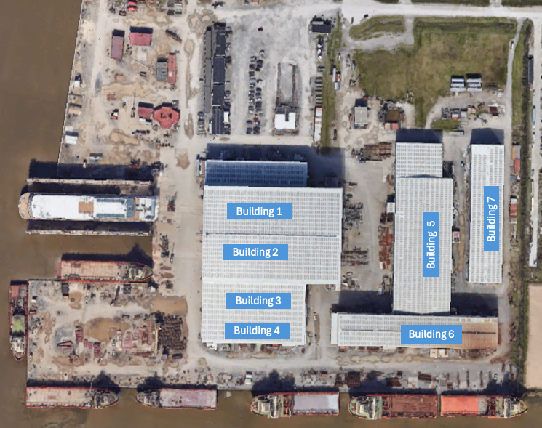
Figure 2-1. The Satellite View of the Facility

Table 2-1. The Operating Hours and Shift Schedule
Department | Shift Start – Shift End | Days/Week | Number of Employees
Main Operation | 6:00 AM – 4:30 PM | 6 | 500
 | 5:00 PM –3:30 AM | 6

Process Description

The ship manufacturing at the industrial facility is a well-organized and efficient workflow that begins with a comprehensive design and drawing phase, typically spanning two months. The initial designs undergo rigorous testing using models and computer-aided software to ensure feasibility and performance. The assembly process follows a systematic approach, beginning at the panel line where boat heads and hulls are constructed using N/C line with automatic welders. The components then move to the main assembly area, where plasma cutting is used for larger pieces, and previously constructed components are integrated into the main body of the ship. Following assembly, the vessel undergoes a painting process using spray coatings. The final and critical phase is the water test, which can extend up to a year, evaluating maneuverability, checking for leaks, and validating the overall design. If the vessel passes these tests, it proceeds to customer delivery; if not, it returns to the design phase for necessary modifications. This comprehensive process ensures the production of high-quality vessels that meet industry standards and customer specifications. The process flow is shown in Figure 2-2.

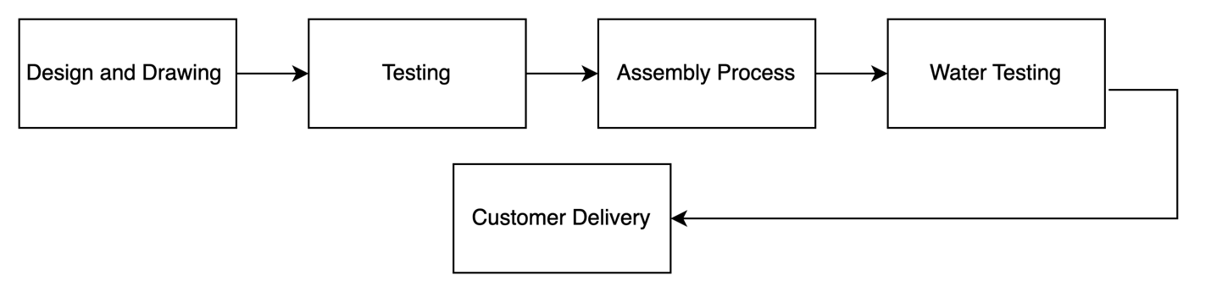
Figure 2-2. The Production Process Flowchart

Historical Energy Usage

The client provided monthly electricity costs and electricity usage of the facility for one year from January 2023 to December 2023, as shown in Figure 2-3 and Figure 2-4, respectively. The electricity rate is estimated at 8.2 cents per kWh. The following findings can be observed from the figures on electricity usage and information from the site visit:
- The electricity charges show significant seasonal variation, with peak costs occurring in February and July-August 2023, reaching approximately $90,000. The lowest charges were observed in the later months of the year (October-December 2023), averaging around $40,000.
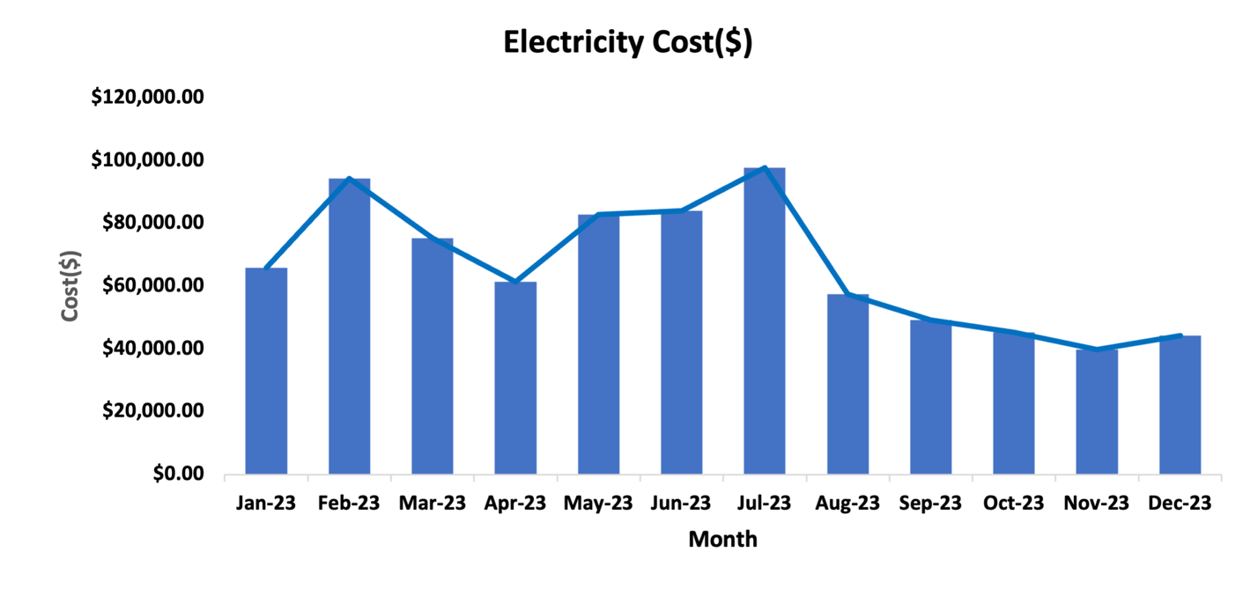
Figure 2-3. Monthly Electricity Cost

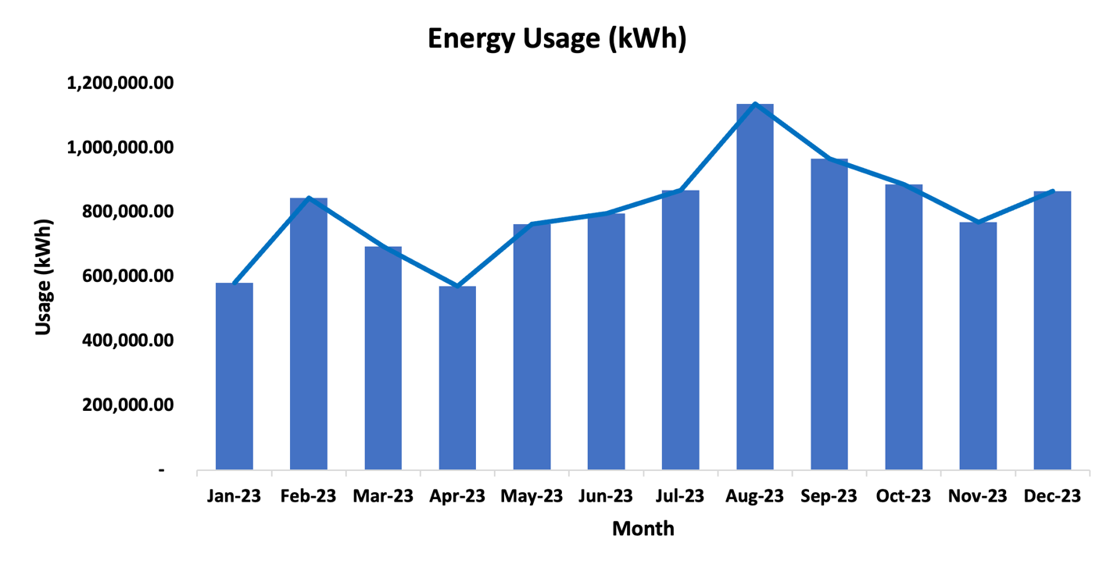
Figure 2-4. Monthly Electricity Usage

Figure 2-4 shows the following observations:

- The peak consumption occurred in August 2023, reaching approximately 1,100,000 kWh, which may indicate peak production at the facility
- The lowest consumption was recorded in April 2023 at about 600,000 kWh
- There is a clear correlation between energy usage and seasonal patterns, with higher usage during summer months (July-September)

The facility’s monthly demand costs are plotted in Figure 2-5. Figure 2-6 demonstrates the monthly demand usage in kW. Based on our analysis, the demand charge is estimated to be $3.05 per kW. The highest demand cost and the peak energy usage occurred from August to October 2023. Figure 2-5 and Figure 2-6 indicate that the demand cost and demand usage (kW) correlate reasonably well with each other.

The facility's monthly demand usage is plotted in Figure 2-5, and Figure 2-6 demonstrates the monthly demand costs in dollars. Based on our analysis, the demand charge is estimated to be $4.50 per kW (calculated from the average ratio of demand cost to demand usage). The demand usage remained relatively stable throughout the year, ranging between 2,000 and 3,000 kW, with slight increases during the summer months. Figure 2-5, and Figure 2-6 indicate that the demand cost and demand usage (kW) have a strong linear correlation, with demand costs consistently ranging between $10,000 and $14,000 throughout the year, showing less seasonal variation compared to overall electricity charges.

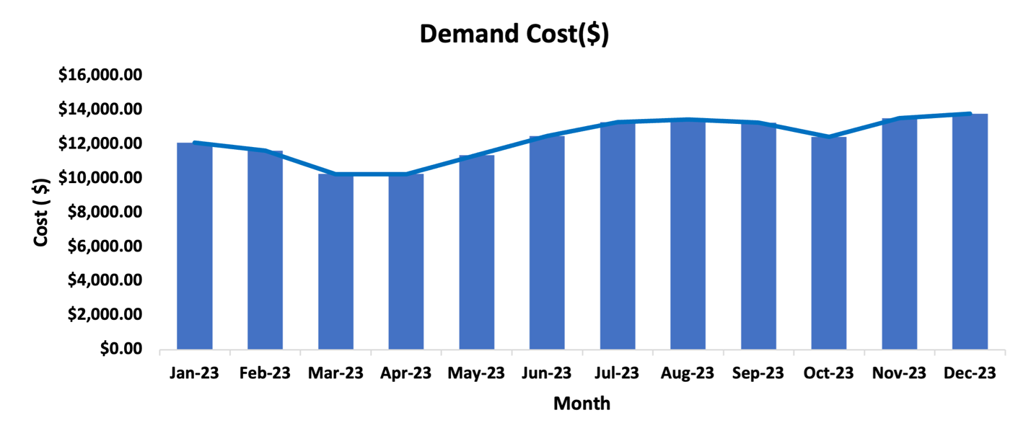
Figure 2-5. Monthly Demand Charge

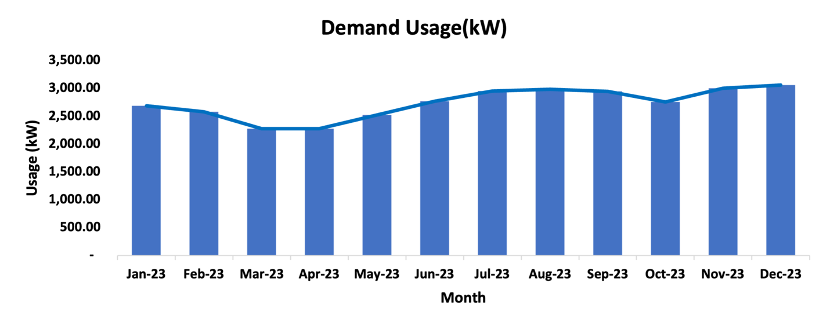
Figure 2-6. Monthly Demand Usage

Major Energy Consuming Equipment and Devices

A list of major equipment and devices is provided in Table 2-2. Figure 2-7 shows how much power is used by each piece of equipment in the facility. This figure indicates that the Welding Machines is the primary power consumer in the facility, accounting for 63% of the total power.

Table 2-2. The Major Power Consuming Equipment
Energy Application | Power (hp) | Quantity | Total Power (hp) | Percentage
Welding Machines | 55 | 200 | 11,000 | 63%
Air Compressors | 504 | 4 | 2,016 | 11%
Dry Dock | 1,833 | 1 | 1,833 | 10%
Panel Line Equipment | 229 | 6 | 1,374 | 8%
Wheelabrator | 733 | 1 | 733 | 4%
Messer Cutting Systems | 321 | 2 | 641 | 4%
Total | 3675 | 214 | 17,597 | 100%

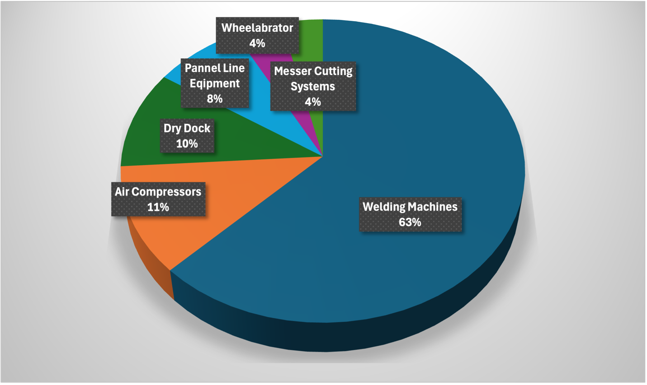
Figure 2-7. The Major Power Consumers

CURRENT BEST PRACTICES

During the visit and discussion with the facility managers, the LSU-ITAC team found that the facility management team currently employs a few good practices, which are briefly described below.

Partial Implementation of LED Retrofits in Facility
The LSU-ITAC team observed that in select areas of the facility, LED lighting fixtures had been installed in place of the previous traditional lighting fixtures, as shown in Figure 3-1While the implementation is not facility-wide, this partial retrofit represents a step toward best practices, as LED consumes less energy to produce the same level of lumen output. Also, LED lighting sources emit less heat when operating compared to traditional lighting fixtures. The areas where LED lighting has been implemented will experience improved energy efficiency, suggesting potential benefits from expanding this retrofit to other sections of the facility.

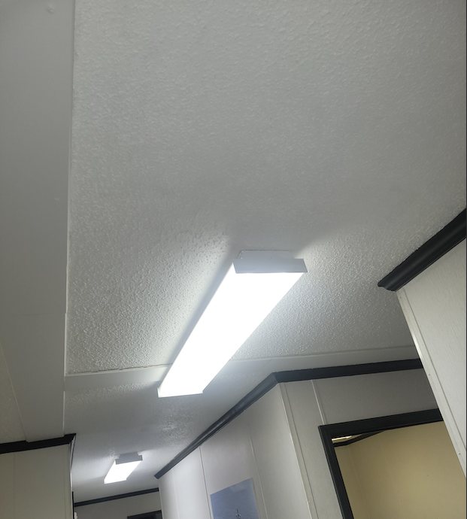
Figure 3-1. LED Retrofits in the Facility.

Recycling of Metal
LSU ITAC observed facility use for recycling Metal because it streamlines resource management and promotes environmental sustainability, as shown in Figure 3-2. By processing and repurposing steel waste, facilities reduce the need for virgin steel, conserving natural resources and lowering production costs. This process minimizes waste generation, reduces disposal costs, and ensures better resource utilization. Recycling Metal also contribute to reducing environmental impact by lowering emissions and conserving energy, supporting a circular economy.

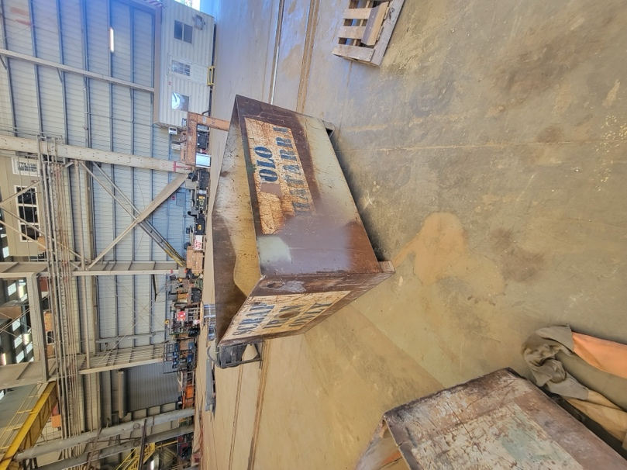
Figure 3-2. Recycling Metals

Use of Robotic Welding System
LSU ITAC observed the facility use of robotic welding systems to enhance manufacturing efficiency and ensure consistent quality, as shown in Figure 3-2 . Robotic welding delivers precision and uniformity, significantly reducing errors and the need for rework. This technology improves production speed and allows facilities to meet high output demands while maintaining superior quality standards. Moreover, robotic welding enhances workplace safety by limiting human involvement in hazardous tasks and reducing material waste through accurate welds.

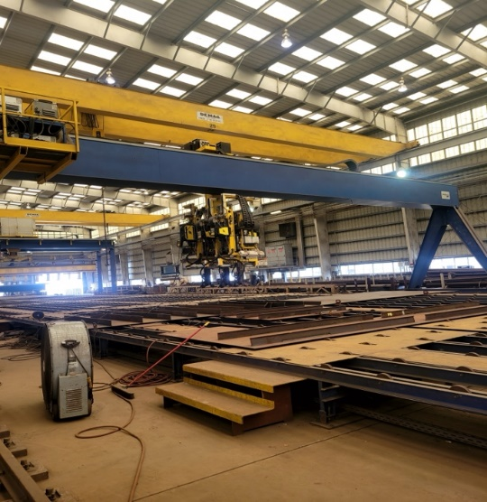
Figure 3-4. Robotic Welding System in the Facility.

Use of Skylights
LSU ITAC observed the use of skylights as an effective strategy to enhance energy efficiency and improve workplace conditions, as shown in Figure 3-2. Skylights allow natural light to illuminate the facility, reducing the dependency on artificial lighting and lowering energy consumption. This practice not only cuts operational costs but also contributes to environmental sustainability by minimizing the facility’s carbon footprint. Additionally, natural light creates a healthier and more comfortable work environment, boosting employee productivity and morale. The integration of skylights is a simple yet impactful best practice that aligns with energy efficiency goals and promotes a sustainable manufacturing process.

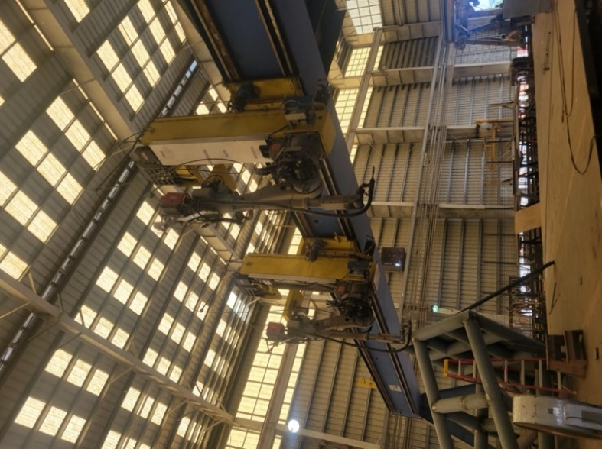
Figure 3-4. Use of Skylights in the Facility.

ASSESSMENT RECOMMENDATIONS (ARS)
This section provides detailed calculations and analyses for the assessment recommendations (ARs).

AR No. 1 – Install Programmable Thermostat in the Office
(ARC Code 2.7261)

Table 4-1. The Savings Summary for AR No. 1
Energy Savings (kWh/yr) | Energy Cost Savings ($/yr) | Total Cost Savings ($/yr) | CO₂ Reduction (Tons/yr) | Imp. Cost  ($) | Payback Period  (yrs)
42,811 | 3,511 | 3,511 | 16 | 40 | 0.01

Observation and Analysis
LSU-ITAC observed that in the four buildings area, there were eight 5-ton cooling units in operation with a total capacity of 40 tons, set at an average temperature of 72°F. These cooling units were controlled by eight programmable thermostats. According to the management team, the thermostats were kept at a constant temperature. Such control strategies will result in unnecessary energy usage by the cooling unit, since the real-time temperature may still be higher than the set points during the off-hours and weekends. If the facility installs the programmable thermostats (see Figure 4-1) in place of the non-programmable thermostats and sets up a temperature schedule on the existing programmable thermostats for the cooling units, there will be energy savings coming from the reduced working hours of the cooling units that otherwise would be working.
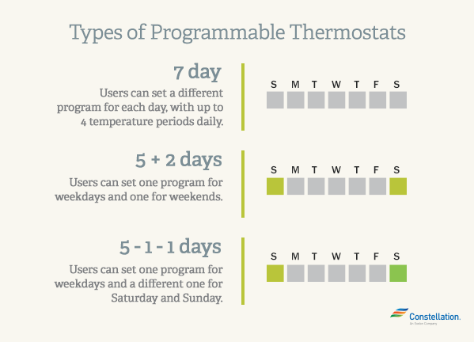
Figure 4-1. The Types of Programmable Thermostats.
Recommendation
We recommend that the facility set up a temperature schedule on the existing programmable thermostats. The thermostats should be programmed such that when the office areas are unoccupied, the setpoints should be raised to 80°F, and revert to their current setpoints an hour before the shift begins. When the indoor temperature is below the setpoint, the cooling units will stop operating. By doing so, the total cooling hours and load will be reduced, resulting in noticeable energy and cost savings.

Calculations
Current Electrical Energy Usage
We assume that the indoor temperature equals the outdoor temperature over a year. The current cooling hours were estimated using TMY3 data specific to the local area, using temperature-bin analysis. The hours' count for the cooling unit when the indoor air temperature is higher than the setpoints and requires cooling over a year is shown in Figure 4-2. The row levels represent the temperature range (°F), and column labels represent the time range of day (hour) for a 24-hour clock period.

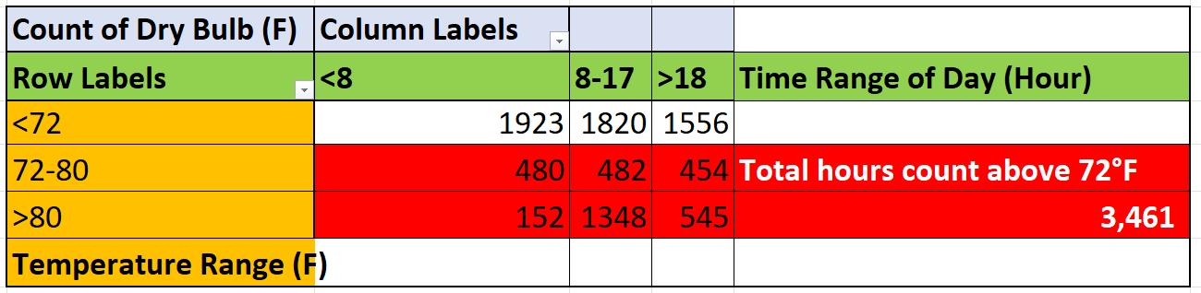
Figure 4-2. The Cooling Hour Count for the Cooling Unit Set at 72°F

From the hour count, we know that there generally have been 3,461 hours in a year when the outside temperature was higher than 72°F. Thus, we can calculate the current cooling energy usage of the cooling units as follows:
EU_{CC} = (RC_{T} × CH₇₂ × LF_{C} / COP_{C}) × K_{T}
= ((40 ton) × 3,461 hrs/yr × 1.0 / 3.28) × 3.5 kW/ton
= 147,726 kWh/yr,
where
EU_{CC} = Current Cooling Energy Usage, kWh/yr
RC_{T} = Total Rate Capacity of Cooling Units, tons
CH₇₂ = Total Cooling Hours in a Year Based on 72°F
LF_{C} = Estimated Load Factor for Cooling Units, estimated at 1.0
COP_{C} = Cooling Coefficient of Performance, estimated at 3.28
K_{T} = Conversion Factor, 3.5 kW/ton

Proposed Electrical Energy Usage
It is recommended that the cooling units start cooling the office an hour before space begins to be occupied. Choosing the time range to show the cooling hours based on 72 – 80°F that fall into shift hours, we change the pivot table, as shown in Figure 4-3.

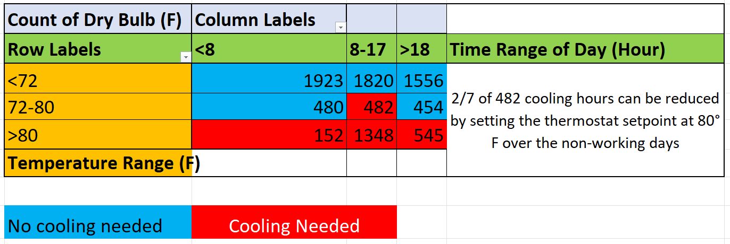
Figure 4-3. The Cooling Hours Count Based on 72 – 80°F in a Proposed Schedule

Since there are six workdays in a seven-day week, 1/7 of the 482 cooling hours based on 72 – 80°F that fall into shift hours can be reduced as it represents non-operational days. Therefore, we estimate that the cooling hours during working hours are as:
CH_{W} = 482 × (6/7) + 152 + 1,348 + 545
= 2,458 hrs/yr,
where
CH_{W} = Cooling Hours during the Working Hours under Proposed Schedule, hrs/yr
CH_{T} = Total Cooling Hours during Working Hours with Weekends included under the Proposed Schedule, hrs/yr

This new setpoint schedule will result in 2,458 annual cooling hours for the office. The proposed cooling setpoints schedule is summarized in Table 4-2.

Table 4-2. The Recommended Settings for Cooling Setpoints
Days | Time | Cooling Setpoint | Estimated Cooling Hours per Year
Monday – Saturday | 8:00 AM – 4:30 PM | Cool: 72°-80° F | 2,458
 | 5:00 PM – 3:30 AM

The proposed cooling energy usage can be calculated as:
EU_{CP} = (RC_{T} × CH_{P} × LF_{C} / COP_{C}) × K_{T}
= ((40 -ton) × 2,458 hrs/yr × 1.0 / 3.28) × 3.5 kW/ton
= 104,915 kWh/yr,
where
EU_{CP} = Proposed Cooling Energy Usage, kWh/yr
RC_{T} = Total Rate Capacity of the Cooling Units, tons
CH_{P} = Total Cooling Hours in a Year Based on Proposed Schedule
LF_{C} = Estimated Load Factor for Cooling Units
COP_{C} = Cooling Coefficient of Performance, estimated at 3.28
K_{T} = Conversion Factor, 3.5 kW/ton

Electrical Energy Savings
The electrical energy savings can be calculated:
ES = EU_{CC} – EU_{CP}
= 147,726 kWh/yr – 104,915 kWh/yr
= 42,811 kWh/yr,
where
ES = Electrical Energy Savings from Cooling, kWh/yr
EU_{CC} = Current Cooling Energy Usage, kWh/yr
EU_{CP} = Proposed Cooling Energy Usage, kWh/yr

Electrical Energy Cost Savings
The electrical energy cost savings can be calculated:
ECS = ES × UR
= 42,811 kWh/yr × $0.082/kWh
= $3,511/yr,
where
ECS = Electrical Energy Cost Savings from Cooling, $/yr
ES = Electrical Energy Savings from Cooling, kWh/yr
UR = Average Electrical Energy Usage Rate, $0.082/kWh

Total Energy Cost Savings
In this case, the total cost savings are equal to the electrical energy cost savings:
TCS = ECS
= $3,511/yr,
where
TCS = Total Cost Savings, $/yr
ECS = Electrical Energy Cost Savings, $/yr

Carbon Dioxide Reduction
Due to the reduced electrical usage, there will also be lower carbon dioxide emissions at the electric power generation. These reductions can be calculated using:
CO₂ = ES × K₁ × K₂
= 42,811 kWh/yr × (0.763 lb. CO₂ / kWh) × 1Ton/2,000lbs
= 16 Tons/yr,
where
CO₂ = Amount of Carbon Dioxide Reduced, Tons CO₂/yr
K₁ = Amount of CO₂ Produced per kWh, 0.763 lb. CO₂/kWh
K₂ = Conversion Factor = 1Ton/2,000lbs

Implementation Cost
The office had eight programmable thermostats. Implementing a new temperature schedule will involve labor costs for an employee to set up all the thermostats, without any material costs. Assuming the labor cost is $25/hr, and the installation and setup time is 0.2 hour per thermostat, the total time required will be (8 × 0.2 hour) = 1.6 hour of labor.

The costs are summarized below in Table 4-3, and the payback period can be calculated as follows:

Table 4-3. The Implementation Cost Summary for AR No. 1
Cost Types | Quantity | Unit Cost | Cost ($)
Labor | 1.6 hr | $25/hour | 40
Total Implementation Cost |  |  | 40

Payback Period
PP = IC / TCS
= $40 / ($3,511/yr)
= 0.01 yrs,
where
PP = Payback Period, yrs
IC = Implementation Cost, $
TCS = Total Cost Savings, $/yr

AR No. 2 – Utilize Daylight Whenever Possible in Lieu of Artificial Light
(ARC Code 2.7121)

Table ‎4-4. The Savings Summary for AR No. 2
Energy Savings (kWh/yr) | Energy Cost Savings ($/yr) | Total Cost Savings ($/yr) | CO₂ Reduction (Tons/yr) | Imp. Cost ($) | Payback Period  (yr)
714,299 | 58,573 | 58,573 | 273 | 1,218 | 0.02

Observation and Analysis
During the assessment tour, the LSU-ITAC team found that some of the lighting fixtures in some of the processing buildings were on throughout the day, even when there was enough daylight through the skylights. The team also observed that outdoor lighting fixtures remained operational during daylight hours. In addition, the illumination, measured using Extech® Light Meter, was utilized in assessing the luminance of such buildings. For indoor areas, especially those with skylights, installing daylight sensors will regulate the number of fixtures based on the amount of natural light available. For outdoor lighting, installing photocell sensors will automatically control the operation based on ambient light levels, turning them off during daylight hours and on during darker periods. These automated controls will help prevent unnecessary electrical energy consumption and optimize the facility's lighting operation. A typical daylight sensor and photocell sensor are shown in Figure ‎4-4.

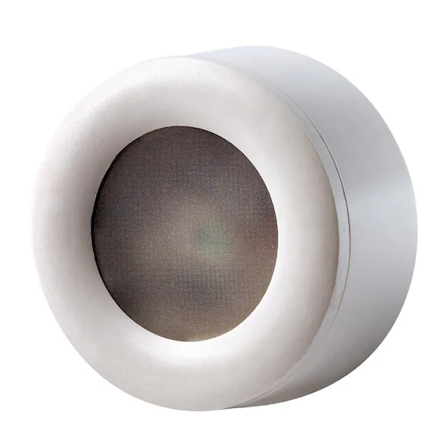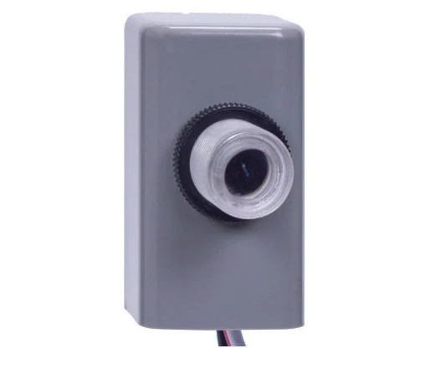
Figure ‎4-4. Daylight Sensor and Photocell Sensor

Recommendation
LSU-ITAC recommends turning off the lights to reduce electricity usage when there is enough daylight. By turning off the lights, the facility will save energy since the lighting fixtures consumed large amounts of power.

Calculations
The total number and power ratings of all lighting fixtures are summarized in Table ‎4-5. We conservatively estimated that by installing the daylight sensor, the wattage consumption would be reduced by 30% based on discussion with the facility personnel regarding it.

Table ‎4-5. The Summary of Lighting Equipment for Sensor Installation
Location | Proposed Sensor Type | Type | Rated Power (W) | Number Lights | Total Power (W)
Building 1 | Daylight Sensor | Metal Halide Sports Lights | 1500 | 33 | 49,500
Building 2 | Daylight Sensor | Metal Halide Sports Lights | 1500 | 34 | 51,000
Building 3 | Daylight Sensor | Metal Halide Sports Lights | 1500 | 27 | 40,500
Building 4 | Daylight Sensor | Metal Halide Sports Lights | 1500 | 27 | 40,500
Pipe Shop | Daylight Sensor | High Bay Light | 400 | 24 | 9,600
Tool Room | Daylight Sensor | High Bay Light | 400 | 12 | 4,800
N.C. Shop | Daylight Sensor | High Bay Lights | 400 | 37 | 14,800
N.C. Shop | Daylight Sensor | Metal Halide Sports Lights | 1500 | 8 | 12,000
Panel Line | Daylight Sensor | High Bay Lights | 400 | 37 | 14,800
Panel Line | Daylight Sensor | Metal Halide Sports Lights | 1500 | 11 | 16,500
Robot/Wheelabrator | Daylight Sensor | Metal Halide Sports Lights | 1500 | 20 | 30,000
Robot/Wheelabrator | Daylight Sensor | Wall Pack Lights | 400 | 5 | 2,000
Total Power for Daylight Sensor (W_{D}) |  |  |  |  | 286,000
Buildings 1-4 Exterior | Photocells | Flood Lights | 400 | 28 | 11,200
Dry Dock | Photocells | Flood Lights | 400 | 24 | 9,600
Panel Line/Wheelabrator Exterior | Photocells | Flood Lights | 400 | 9 | 3,600
Pedestal Lights (Yard) | Photocells | Metal Halide Sports Lights | 1000 | 53 | 53,000
Total Power (W) |  |  |  |  | 363,400

Current Energy Usage
The amount of current annual energy usage can be calculated using the following equation:
EU_{C} = W × CF × LH
= 363,400 W × 0.001 kW/W × 6,552 hrs/yr
= 2,380,997 kWh/yr
where
EU_{C} = Current Annual Energy Usage, kWh/yr
W = Total Wattage of Lights
CF = Conversion Factor (kW/W) = 0.001
LH = Lighting Hours = 6,552 hrs/yr

Proposed Energy Usage
The proposed annual electricity usage can be calculated as follows:
EU_{P} = W × CF × LH × RF
= 363,400 W × 0.001 kW/W × 6,552 hrs/yr × 0.7
= 1,666,698 kWh/yr,
where
EU_{P} = Proposed Annual Energy Usage, kWh/yr
W = Total Wattage of Lights
CF = Conversion Factor (kW/W) = 0.001
LH = Lighting Hours = 6,552 hrs/yr
RF = Reduction Factor due to Daylight and Photocell Sensors

Electrical Energy Savings
The total amount of electrical energy savings for this implementation can be calculated as:
ER = EU_{C} – EU_{P}
= 2,380,997 kWh/yr – 1,666,698 kWh/yr
= 714,299 kWh/yr,
where
ER = Energy Reduction, kWh/yr
EU_{C} = Total Current Annual Energy Usage, kWh/yr
EU_{P} = Proposed Annual Energy Usage, kWh/yr

Electrical Energy Cost Savings
The total energy cost savings can be calculated using:
ECS = ER × UR
= 714,299 kWh/yr × $0.082/kWh
= $58,573/yr,
where
ECS = Total Energy Cost Savings, $/yr
ER = Energy Reduction, kWh/yr
UR = Average Electrical Energy Usage Rate = $0.082/kWh

Total Cost Savings
In this case, the total cost savings are the electrical energy cost savings:
TCS = ECS
= $58,573/yr,
where
TCS = Total Cost Savings
ECS = Total Electrical Energy Cost Savings, $/yr

Carbon Dioxide Reduction
Due to the reduced electrical usage, there will also be lower carbon dioxide emissions from the electric power generation. These reductions can be calculated using:
CO₂ = ER × K₁ × K₂
= 714,299 kWh/yr × (0.763 lb. CO₂ / kWh) × 1 Ton/2,000lb
= 273 Ton/yr,
where
CO₂ = Amount of Carbon Dioxide Reduced, Tons CO₂/yr
ER = Electrical Energy Reduction, kWh/yr
K₁ = Amount of CO₂ Produced per kWh = 0.763 lb. CO₂/kWh
K₂ = Conversion Factor = 1 ton/2,000 lbs

Implementation Cost
Implementation will involve the cost of daylight and the cost of installation. It is estimated that the average cost of a daylight sensor is $1304F,,. We approximate that the indoor lighting zones can be controlled by 28 of these daylight sensors. The same way the facility would need 14 photocell sensors to control the outdoor lights. The average cost of the photocell sensor is $12 . The installation cost is $25/hr for both and it takes 1 hour to install each sensor. Also, Entergy has a rebate program6F available in daylight sensor installation. According to the prescriptive incentive rates requirement, the facility qualifies as a large commercial entity since its monthly peak demand exceeds 100 kW. The incentive rate is $0.11/W of light covered by sensors. Entergy only gives incentives on whichever is lower among material cost and electrical energy cost savings. The total implementation cost can be estimated by:

IC = (DC × DN – IO × W_{D}) + (PC × PN) + LR × LT
= ($130 × 28 – $0.11/W × 286,000 W) + ($12 × 14) + $25/hour × 42 hours
= $0 (material DC) + $168 (material PC) + $1,050 (labor)
= $1,218
where
IC = Implementation Cost,
DC = Cost per Daylight Sensor, $
PC = Cost per Photocell Sensor, $
DN = Number of Daylight Sensors Needed,
PN = Number of Photocell Sensors Needed,
IO = Incentive Rate for Daylight Sensor Installation, $0.11/W
W_{D} = Collective Wattage for Daylight Sensor Installment, W
LR = Labor Rate, $/hour
LT = Labor Time for Sensor Installation, hour

The implementation cost is shown in Table ‎4-6.

Table ‎4-6. The Implementation Cost Summary for AR No. 2
Item | Quantity | Unit Cost | Incentives7F | Cost ($)
Material (Daylight Sensor) | 28 | $130/unit | $0.11/W | 0
Material (Photocell) | 14 | $12 | - | 168
Labor | 42 hrs | $25/hr | - | 1,050
Total Implementation Cost |  |  |  | 1,218

Payback Period
PP = IC / TCS
= $1,218/ ($58,573/yr)
= 0.02 yrs,
where
PP = Payback Period, yrs
IC = Implementation Cost, $
TCS = Total Cost Savings, $/yr

  - AR No. 3 – Utilize Higher Efficiency Lamps and/or Ballasts
(ARC Code 2.7142)

Table 4-7. The Savings Summary for AR No. 3
Energy Savings (kWh/yr) | Energy Cost Savings  ($/yr) | Demand Savings  (kW/yr) | Demand Cost  ($/yr) | Total Cost Savings ($/yr) | CO₂  Reduction (tons/yr) | Imp. Cost ($) | Payback Period  (yrs)
1,908,279 | 156,516 | 3,496 | 15,732 | 172,248 | 728 | 79,397 | 0.46

Observation and Analysis
During the assessment tour, the team found that the facility used fluorescent lighting fixtures and some LED lights throughout the warehouse on-site (see Figure 4-5). Our team observed that there would be potential for cost savings once all fluorescent lighting fixtures are replaced with energy-efficient LEDs. The current lighting fixtures are used during usual shift hours. In total, the number and power ratings of all fluorescent lighting fixtures are summarized in Table 4-8.

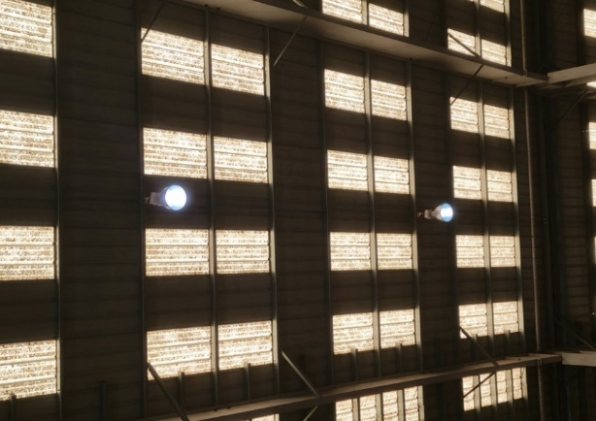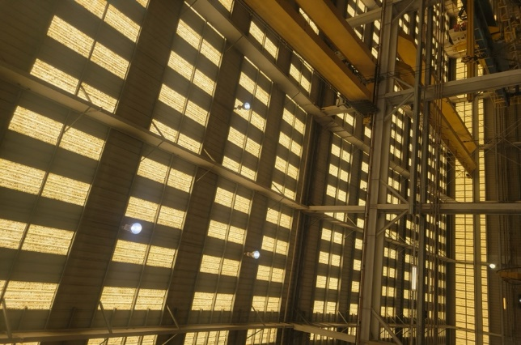
Figure 4-5. Metal Halide Bulbs in Facility

Table 4-8. The Summary of Existing Lighting Equipment in the Facility
Location | Type | Rated Power (W) | Number Lights | Total Power (W)
Building 1 | Metal Halide Sports Lights | 1500 | 33 | 49,500
Building 2 | Metal Halide Sports Lights | 1500 | 34 | 51,000
Building 3 | Metal Halide Sports Lights | 1500 | 27 | 40,500
Building 4 | Metal Halide Sports Lights | 1500 | 27 | 40,500
Pipe Shop | High Bay Light | 400 | 24 | 9,600
Tool Room | High Bay Light | 400 | 12 | 4,800
N.C. Shop | High Bay Lights | 400 | 37 | 14,800
N.C. Shop | Metal Halide Sports Lights | 1500 | 8 | 12,000
Panel Line | High Bay Lights | 400 | 37 | 14,800
Panel Line | Metal Halide Sports Lights | 1500 | 11 | 16,500
Robot/Wheelabrator | Metal Halide Sports Lights | 1500 | 20 | 30,000
Robot/Wheelabrator | Wall Pack Lights | 400 | 5 | 2,000
Buildings 1-4 Exterior | Flood Lights | 400 | 28 | 11,200
Building 1 (Stairwells) | High Bay Lights | 400 | 10 | 4,000
Dry Dock | Flood Lights | 400 | 24 | 9,600
Panel Line/Wheelabrator Exterior | Flood Lights | 400 | 9 | 3,600
Pedestal Lights (Yard) | Metal Halide Sports Lights | 1000 | 53 | 53,000
Total Power (W) |  |  |  | 367,400

Recommendation
For the maximum cost and environmental benefits, our team recommends upgrading all the facility’s lighting equipment with LED lights. The advantages of LED lights are that the LED lights can work without a ballast, have much lower-rated power, and maintain their initial lumen outputs while lasting longer than fluorescent lights. Additionally, the LED lights produce much less heat when in operation. The facility can gradually phase out the current lighting equipment every time a piece burns out and mount the new LED ones. The facility can switch out the current fluorescent lighting fixtures with the replacement of LED that is rated, as shown in Table 4-9.

Table 4-9. The Summary of Recommended Lighting Equipment in the Facility
Type | Rated Power/ea. (W) | Quantity | Total Power (W)
LED Corn Bulb | 250 | 213 | 53,250
LED High Bay Lamps | 120 | 120 | 14,400
LED Flood Lights | 130 | 61 | 7,930
LED Wall Pack Lights | 100 | 5 | 500
Total Power (W) |  |  | 76,080

Calculations
Current Energy Usage
The current fluorescent lights run for the ordinary shift hours. Therefore, current energy consumption for lighting can be estimated as follows:
EU_{c} = W_{c} × OH × CF
= 367,400 × 6,552 hrs/yr × 0.001 kW/W
= 2,407,205 kWh/yr,
where
EU_{c} = Current Annual Energy Usage, kWh/yr
W_{c} = Collective Wattage of All Lights
OH = Operation Hours for Lights = 21 hrs/day × 6 days/week × 52 weeks/yr = 6,552 hrs/yr
CF = Conversion Factor (kW/W) = 0.001

Proposed Energy Usage
After the facility upgrades all fixtures to LED, the annual electricity usage can be calculated as follows:
EU_{P} = W_{P} × OH× CF
= 76,080 W × 6,552 hrs/yr × 0.001 kW/W
= 498,476 kWh/yr,
where
EU_{P} = Proposed Annual Energy Usage, kWh/yr
W_{P} = Collective Wattage of Proposed LED Tubes
OH = Operation Hours for Lights = 21hrs/day × 6 days/week ×52 weeks/yr = 6,552 hrs/yr
CF = Conversion Factor (kW/W) = 0.001

Electrical Energy Savings
The total amount of electrical energy savings for this implementation can be calculated:
ER = EU_{C} – EU_{P}
= 2,407,205 kWh/yr – 498,476 kWh/yr
= 1,908,279 kWh/yr,
where
ER = Electrical Energy Reduction, kWh/yr
EU_{C} = Current Electrical Energy Usage, kWh/yr
EU_{P} = Proposed Electrical Energy Usage, kWh/yr

Electrical Energy Cost Savings
The total electrical energy cost savings with the replacement of all the current lights with LED lights in the facility can be estimated by the following equation:
ECS = ER × UR
= 1,908,279 kWh/yr × $0.082/kWh
= $156,516/yr,
where
ECS = Total Electrical Energy Cost Savings, $/yr
ER = Electrical Energy Reduced, kWh/yr
UR = Average Electrical Energy Usage Rate = $0.082/kWh

Electrical Demand Savings
The total amount of electrical demand savings can be calculated using the following equation:
EDS = (W_{c} –W_{p}) × CF × 12 months
= (367,400 W – 76,080 W) × 0.001 × 12 months
= 3,496 kW/yr,
where
EDS = Estimated Demand Savings, kW/yr
W_{c} = Collective Wattage of Current Lights
W_{p} = Collective Wattage LED Tubes
CF = Conversion Factor (kW/W) = 0.001

Electrical Demand Cost Savings
By lowering the amount of energy, the facility uses during its peak demand period, there will be a lower demand charge. The amount of energy demand cost savings (EDCS) can be estimated using the following equation:
EDCS = EDS × DR
= 3,496 kW/yr × $4.500/kW
= $15,732 /yr,
where
EDCS = Estimated Demand Cost Savings, $/yr
EDS = Electrical Demand Savings, kW/yr
DR = Demand Charge = $4.500/kW

Total Cost Savings
Since there has been a demand charge on the facility, the total cost savings is the sum of electrical energy cost savings and estimated demand cost savings:
TCS = ECS + EDCS
= $156,516/yr + 15,732 /yr
= $172,248 /yr,
where
TCS = Total Cost Savings, $/yr
ECS = Total Electrical Energy Cost Savings, $/yr
EDCS = Estimated Demand Cost Savings, $/yr

Carbon Dioxide Reduction
Due to the reduced electrical usage, there will also be lower carbon dioxide emissions from the electrical power generation. These reductions can be calculated using:
CO₂ = ER × K₁ × K₂
= 1,908,279 kWh/yr × (0.763 lb CO₂ / kWh) × 1 Ton/2,000lbs
= 728 Tons/yr,
where
CO₂ = Amount of Carbon Dioxide Reduced, Tons/yr
ER = Electrical Energy Reduction, kWh/yr
K₁ = Amount of CO₂ Produced per kWh, 0.763 lb CO₂/kWh
K₂ = Conversion Factor = 1 Ton/2,000 lbs

Implementation Cost
Implementation will involve the labor cost required to replace the lighting fixtures, along with the material cost of the LED lighting equipment (see Figure 4-6). It is assumed that the labor cost is $25/hour, with the time needed for the replacement to be 0.5 hours per fixture for LED lamps.
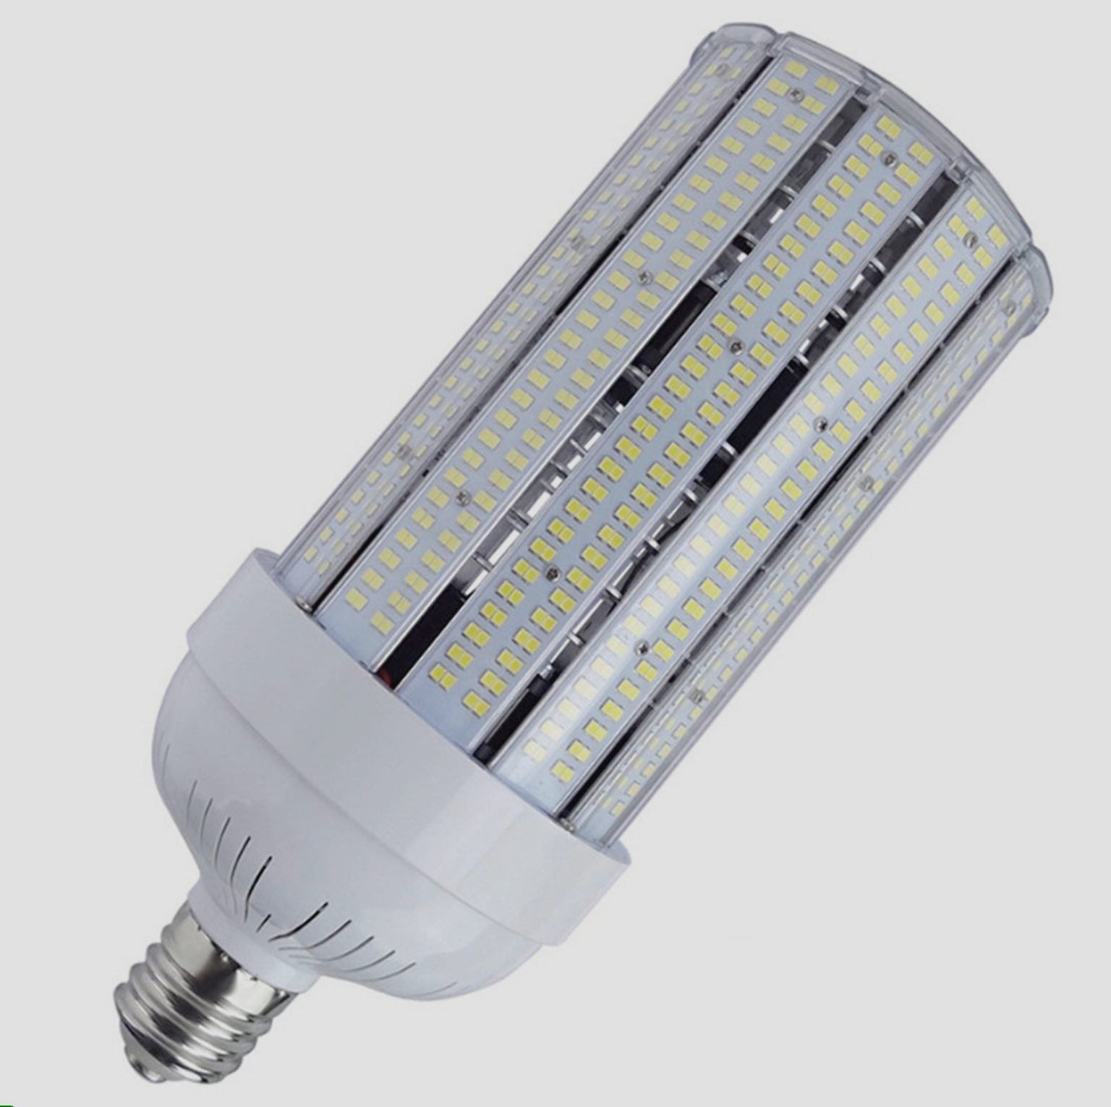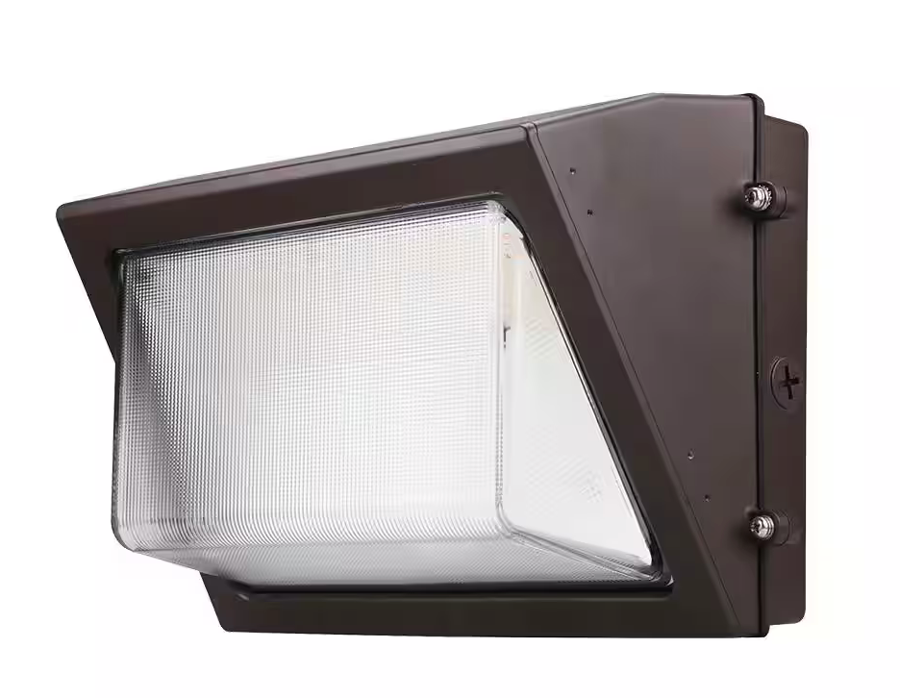
Figure 4-6. Recommended LED Lighting Types

Also, Entergy has a rebate program available in LED lighting fixture retrofit. According to the prescriptive incentive rates requirement, the facility qualifies as a large commercial entity since its monthly peak demand is more than 100 kW. The incentive rates vary by bulb type, with $240/fixture for LED Corn Bulbs, $70/fixture for High Bay Lights, $80/fixture for Flood Lights, and $80/fixture for Wall Pack Lights. The total implementation cost can be estimated by:

IC = N_{corn} × (UC_{corn} – I_{corn}) + N_{highbay} × (UC_{highbay} – I_{highbay}) + N_{flood} × (UC_{flood} – I_{flood}) + N_{wall} × (UC_{wall} – I_{wall}) + LR × LT × N
= 250 × ($270/tube – $240/tube) +120 × ($145/tube – $70/tube) + 61 × ($222/tube – $80/tube) + 5 × ($101/tube – $80/tube) + $25/hour × 0.5 hours/fixture× 436 fixtures
Since the incentive can only be a maximum of $25,000
= $73,947 (material)+ $5,450 (labor)
= $79,397
where
IC = Implementation Cost, $
N_{corn} = Number of LED Corn Bulbs
N_{highbay} = Number of LED High Bay Lights
N_{flood} = Number of LED Flood Lights
N_{wall} = Number of LED Wall Pack Lights
UC_{corn} = Cost per LED Corn Bulbs, $/bulb
UC_{highbay} = Cost per LED High Bay Lights, $/bulb
UC_{flood} = Cost per LED Flood Lights, $/bulb
UC_{wall} = Cost per LED Wall Pack Lights, $/bulb
UC_{4ftT8} = Cost per 4ft T8 LED Tube, $/tube
I_{corn} = Incentive Rate for Replacing LED Corn Bulbs, $/bulb
I_{highbay} = Incentive Rate for Replacing LED High Bay Lights
I_{flood} = Incentive Rate for Replacing LED Flood Lights
I_{wall} = Incentive Rate for Replacing LED Wall Pack Lights
LR = Labor Rate, $/hour
LT = Labor Time per Fixture Replacement, hour/fixture
N = Total Number of Fixtures
Since the incentive cannot be greater than $25,000, the facility can get the maximum value of $25,000 as an incentive. The implementation cost is summarized in Table 4-10.

Table 4-10. The Implementation Cost Summary for AR No. 3
Item | Quantity | Unit Cost | Cost ($)
LED Corn Bulb (250W) | 250 | $270/fixture | 67,500
LED High Bay Lights (120W) | 120 | $145/fixture | 17,400
LED Flood Lights (130W) | 61 | $222/fixture | 13,542
LED Wall Pack Lights (100W) | 5 | $101/fixture | 505
Incentive | - | - | -25,000
Total Material Cost | - | - | 73,947
Labor | (0.5 hours/fixture for 436 fixtures) = 218 hrs | $25/hr | 5,450
Implementation Cost ($) | - | - | 79,397

Payback Period
PP = IC/TCS
= $79,397 / ($172,248/yr)
= 0.46 yrs,
where
PP = Payback Period, yrs
IC = Implementation Cost, $
TCS = Total Cost Savings, $/yr

  - AR No. 4 – Upgrade Controls on Air Compressor System
(ARC Code 2.4224)

Table 4-11. The Savings Summary for AR No. 4
Energy Savings (kWh/yr) | Energy Cost Savings ($/yr) | Total Cost Savings ($/yr) | CO₂ Reduction (tons/yr) | Imp. Cost ($) | Payback Period  (yrs)
208,546 | 17,101 | 17,101 | 80 | 12,500 | 0.73

Observation and Analysis
During the team visit, it was noted that the four air compressors operated separately, functioning as individual units. Each compressor had its setpoints and provided compressed air to the assigned machines. There’s no existence of a central monitoring unit on-site, but there is potential for system enhancement through the implementation of an advanced centralized or master controller (optimizer). The upgraded controls possess the capability to regulate variable speed drives to accommodate fluctuating demand while minimizing the operation of fixed-speed machines in an unloaded state whenever feasible, reducing pressure and flow setpoint. The air compressor specification is shown in Figure 4-7.

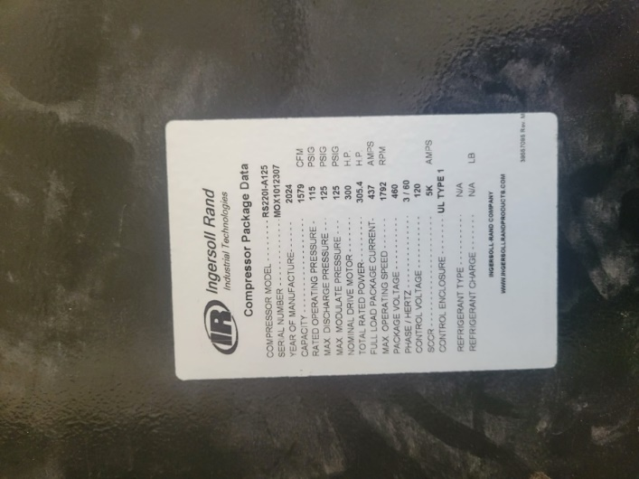
Figure 4-7. Air Compressor Specification

Recommendation
The LSU-ITAC team recommends upgrading controls on the integrated air compressors. The capabilities of the central controller extend to improve efficiency, reliability, and connectivity. The master controller unlocks the energy-saving capabilities of Variable Speed Drive (VSD) units by effectively managing VSDs, adjusting to fluctuating demand while minimizing the operation of fixed-speed machines in an unloaded state whenever feasible (setpoint and flow control). Furthermore, in Industry 4.0, machine connectivity is essential for data analysis by both the system and personnel managing the units. Upgraded controls facilitate this connectivity, linking compressors, blowers, and dryers for monitoring and analysis through Local Area Network (LAN) or a cloud-based system, offering diverse ways to monitor your air system's performance,.

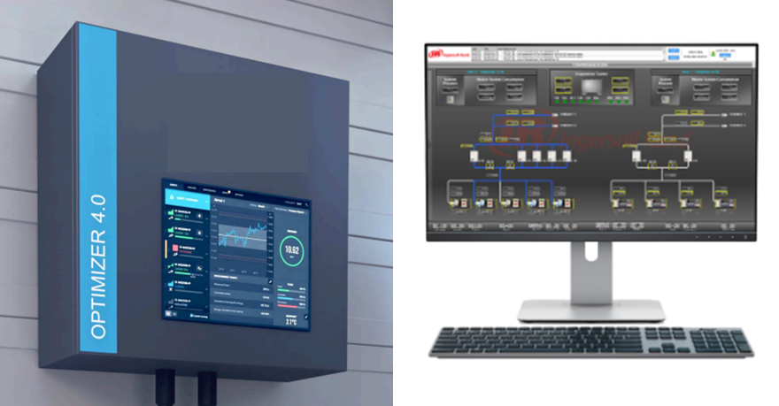
Figure 4-8. Optimizer and Master Controller for Air Compressor System

Calculations
Current Energy Usage
The estimated energy savings for this implementation are realized through calculations based on the reduced pressure setpoint as the current controls have VSD capabilities. This ensures embedded flow bands so that flow is always within the demand, reducing the energy cost related to excess airflow. Furthermore, it reduces the average pressure band and operating pressure for fed systems.

EC_{o} = $\frac{P_{hp}×C×PF}{η}×Hrs×N$
= $\frac{300 hp × 0.746 × 0.80}{0.9}$ × 6,552 × 4
= 5,213,645 kWh/yr,
where,
EC_{o} = Current Annual Energy Consumption of Motors on Dust Collector, kWh/yr
P_{hp} = Motor Nameplate Horsepower, HP
C = Conversion Factor = 0.746 kW/HP
PF = Power Factor = 0.80
$η$ = Estimated Motor Efficiency = 0.9
Hrs = Annual Hour of Operation = 6,552 hrs/yr
N = Number of the Motors = 4

Recommended Energy Use
The energy consumption of the air compressor decreases by approximately 1.6 to 2 percent with a 2 psi reduction in the discharge pressure of the air compressor. Thus, for every 1 psi pressure reduction, the energy savings will be (1.6 / 2) percent = 0.8 percent, which equals 0.008. The amount of annual energy consumption with pressure reduction can be calculated using the following equation:

EU_{R} = EU_{C} $×\left(1-S\right)$
= EU_{C} $×\left(1-0.008×∆P\right)$
= 5,213,645 kWh/yr $×$ (1 – 0.008 $×$ 5)
= 5,005,099 kWh/yr,
where
EU_{R} = Recommended Annual Energy Usage
EU_{C} = Total Current Annual Energy Usage, kWh/yr
S = Power Reduction
$∆P$ = Pressure Reduction, 5 psi

Electrical Energy Savings
Using the total current and recommended energy usage for the air compressor, we can calculate the total annual energy savings for the pressure reduction in the following equation:
ER = EU_{C} – EU_{R}
= 5,213,645 kWh/yr – 5,005,099 kWh/yr
= 208,546 kWh/yr,
where
ER = Energy Reduction
EU_{C} = Total Current Annual Energy Usage, kWh/yr
EU_{R} = Proposed Annual Energy Usage, kWh/yr

Electrical Energy Cost Savings
Using the average electricity use for the facility, we can calculate the total annual energy cost savings in the following equation:
ECS = ER $×$ UR
= 208,546 kWh/yr $×$ $0.082/kWh
= $17,101/yr,
where
ECS = Total Energy Cost Savings, $/yr
ER = Energy Reduction, kWh/yr
UR = Average Electrical Energy Usage Rate = $0.082/kWh

Total Cost Savings
In this case, the total cost savings are the same as energy cost savings, and can be calculated using:
TCS = ECS
= $17,101/yr,
where
TCS = Total Cost Savings, $/yr
ECS = Total Energy Cost Savings, $/yr

Carbon Dioxide Reduction
Due to the reduced electrical usage, there will also be lower carbon dioxide emissions in the electric power generation. These reductions can be calculated using:
CO₂ = ER × K₁ × K₂
= 208,546 kWh/yr × (0.763 lb. CO₂ / kWh) × 0.0005 ton/lb
= 80 Tons/yr,
where,
CO₂ = Amount of Carbon Dioxide Reduced, Tons CO₂/yr
ER = Electricity Consumption Reduction, kWh/yr
K₁ = Amount of CO₂ Produced per kWh = 0.763 lbs. CO₂/kWh
K₂ = Conversion Factor = 0.0005 ton/lb

Implementation Cost
Implementing the utilization of a central controller will require the purchase of the central or master controller and the cost of connecting the system with the air compressors. The cost of the system varies with the facility process design and specific needs. The online quote for a similar system is around $10,000 to purchase. We estimated the cost of installation to be 25% of the material cost.
IC = Cc × Ic
= $10,000 × (25% of $10,000)
= $ 12,500
where
IC = Implementation Cost, $
Cc = Cost of Central Controller, $
Ic = Installation Cost, $

The implementation cost for the recommendation is summarized in Table 4-12.

Table 4-12. The Implementation Cost Summary for AR No. 4
Item | Cost ($)
Central Controller | 10,000
Installation Cost | 2,500
Total Implementation Cost | 12,500

Payback Period
PP = IC / TCS
= $12,500 / ($17,101/yr)
= 0.73 yrs,
where
PP = Payback Period, yrs
IC = Implementation Cost, $
TCS = Total Cost Savings, $/yr

- INDUSTRIAL CONTROL SYSTEMS CYBERSECURITY ASSESSMENT
The Industrial Control Systems (ICSs) Cybersecurity Assessment Tool developed by the U.S. Department of Energy can be used to identify cybersecurity risks in small- and medium-sized manufacturing facilities. This assessment tool is based on a questionnaire to be answered by the facility's IT personnel during the assessment, as shown in Table ‎5-1. This tool can be used to identify risk areas, provide cybersecurity awareness information, potential solutions, and suggest action items based on the response selected. Due to privacy, this client declined to answer the assessment questions, but we add this tool here for the client's self-assessment later if they decide to.
Table ‎5-13. Industrial Control Systems Cybersecurity Assessment Details
People
1 | Does your plant or facility provide basic cybersecurity awareness training to all employees? | No Comments
 | No Response
2 | Are staff assigned and trained to take appropriate measures during a cybersecurity incident? | No Comments
 | No Response
3 | Do your industrial control system (ICS) vendors provide remote support? | No Comments
 | No Response
4 | What level of on-site physical security does your facility or plant enforce upon vendors? | No Comments
 | No Response
5 | Do third party vendors have proper cybersecurity training? | No Comments
 | No Response
6 | Do vendors utilize their own equipment, hardware, or software during site visits? | No Comments
 | No Response
Process
7 | Have you identified critical equipment in your plant or facility that would cause disruption to your operations if they were compromised? | No Comments
 | No response
8 | Does a plan exist to identify and isolate impacted assets, or shut down equipment as necessary in the event of a cybersecurity incident? | No Comments
 | No Response
9 | Does your plant or facility have a cybersecurity incident response procedure? | No Comments
 | No Response
10 | Does a central repository containing equipment schematics, IT infrastructure drawings, and system network layouts exist within the facility? | No Comments
 | No Response
11 | Is cybersecurity considered when purchasing supplies or equipment, and is it defined in your contractual obligations with vendors? | No Comments
 | No Response
12 | Does plant/facility equipment get regularly or automatically scanned for cybersecurity issues (e.g., malware, etc.)? | No Comments
 | No Response
13 | Is the use of external media by staff and vendors regulated within the plant/facility and scanned for cybersecurity issues? | No Comments
 | No Response
Technology
14 | Which of the following best describes the industrial controls in your plant or facility? | No Comments
 | No Response
15 | Are indicators or alerts set up on critical equipment to indicate unusual changes to operating parameters, multiple login attempts, or detect other anomalies in use? | No Comments
 | No Response
16 | Does the plant or facility have any equipment that is programmable or reconfigurable by remote staff? | No Comments
 | No Response
17 | Does your industrial control system (ICS) allow remote access? | No Comments
 | No Response
18 | Are there processes in your plant with operating parameters that are interdependent with other processes? | No Comments
 | No Response
19 | How are modifications to parameters or set-points made within your manufacturing process? | No Comments
 | No Response
20 | Do the computers that run your industrial control system (ICS) allow employees or vendors to import files from external media? | No Comments
 | No Response
Overall Risk: -

https://www.entergy.com/userfiles/content/environment/docs/EntergyClimateScenarioAnalysis.pdf
https://www.eia.gov/environment/emissions/co2_vol_mass.php
https://www.homedepot.com/p/Leviton-Photocell-Indoor-Sensor-1-70-ft-Candles-White-ODC0P-W/301420056?mtc=SHOPPING-CM-CML-BNG-D27-027_002_WIRING_DEVIC-NA-NA-NA-PLALIA-4035595-NA-NA-NA-NBR-NA-NA-NA-2023&cm_mmc=SHOPPING-CM-CML-BNG-D27-027_002_WIRING_DEVIC-NA-NA-NA-PLALIA-4035595-NA-NA-NA-NBR-NA-NA-NA-2023-71700000108163779-58700008321068990-92700075652523498&gclid=fa779a81105b161577e4fe07b22a4587&gclsrc=3p.ds&msclkid=fa779a81105b161577e4fe07b22a4587&utm_source=bing&utm_medium=cpc&utm_campaign=SHOPPING-CM-CML-BNG-D27-027_002_WIRING_DEVIC-NA-NA-NA-PLALIA-4035595-NA-NA-NA-NBR-NA-NA-NA-2023&utm_term=4577060754055676&utm_content=Wiring%20Devices%20-%20All%20Product%20Types
https://www.walmart.com/ip/Sensor-Switch-SBOR-10-ODP-EB3-WH-3V-Long-Range-Fixture-Mt-Occupancy-Sensor-Photocell-3-Vdc/876176166?wmlspartner=wlpa&selectedSellerId=3198&adid=22222222222288729265&wmlspartner=wmtlabs&wl0=e&wl1=o&wl2=c&wl3=75247940989413&wl4=pla-4578847486431166&wl5=&wl6=&wl7=&wl10=Walmart&wl11=Online&wl12=876176166_10000003319&wl14=photocell%20indoor%20sensor&veh=sem&gclid=713a68cbac3218d0c5870c4d0903d673&gclsrc=3p.ds&msclkid=713a68cbac3218d0c5870c4d0903d673
https://prosupplydirect.com/psdjv88qcttl/?msclkid=bcd7e4cb707618bd2839834bdedd0e68
https://www.amazon.com/Woods-59411WD-Outdoor-Hardwired-Photocell/dp/B003YXBJZU?th=1
https://www.homedepot.com/p/Intermatic-500-Watt-120-Volt-Dusk-to-Dawn-Light-Control-Mini-Button-Photocontrol-Black-K4621D89/310486264
https://www.1000bulbs.com/product/5221/PMC-T168.html
https://cdn.entergy-louisiana.com/userfiles/content/energy_efficiency/docs/Commercial-CI-Incentives.pdf
https://cdn.entergy-louisiana.com/userfiles/content/energy_efficiency/docs/Commercial-CI-Incentives.pdf
https://www.youtube.com/watch?v=Zjw2UXVJaS0
https://cdn.entergy-louisiana.com/userfiles/content/energy_efficiency/docs/Commercial-CI-Incentives.pdf?_gl=1*1mkb2of*_ga*ODEzMDkyMTEwLjE2NzQ5MjgxNTE.*_ga_8YKL3FLBBC*MTY3NTYwNzE0OC42LjEuMTY3NTYwODQ4OC4wLjAuMA..*_ga_HK6YSZ6LT0*MTY3NTYwNzE0OC42LjEuMTY3NTYwODQ4OC4wLjAuMA..*_ga_2KJW590NWN*MTY3NTYwNzE0OC42LjEuMTY3NTYwODQ4OC4wLjAuMA..&_ga=2.69482192.1311610344.1675607149-813092110.1674928151
https://ledglobalsupply.com/led-corn-bulbs/open-fixture-led-corn-bulbs/250-watt-led-corn-bulb-replaces-1500-watt-hid-37500-lumens-internal-driver-polycarbonate-covered-leds-dlc-listed-10-year-warranty/?srsltid=AfmBOopjRX6yQ7Orgq1obgNXhbHKeV-ZD3ITIf-sFbpP_K6comfJV4z8AWk&gQT=1
https://www.homelectrical.com/led-low-high-bay-retrofit-kit/ledvance-sylvania-syl-41412.1.html?srsltid=AfmBOoq1g0IeSIDSn6v1YGOFBD30lYNp1QfOslHjClSYEmIVciAaSc-CYPg&gQT=1
https://www.citylightsusa.com/RAB-X34XLTW/
https://www.homedepot.com/p/ETI-LIGHTING-400-Watt-Equivalent-TWPK2-Integrated-LED-Bronze-Wall-Pack-Light-Adjustable-9500-14500-Lumens-and-CCT-with-Photocell-61505201/327620716?source=shoppingads&locale=en-US&srsltid=AfmBOorJOlMdb_JZFwQ1BaTSeAvolswAwwtxMjwR-9td32g3Ti7NowPnvPs&gQT=1#overlay
https://www.ingersollrand.com/it-it/air-compressor/air-compressor-controllers/air-compressor-manager
https://www.atlascopco.com/en-us/compressors/digitalbrochures/optimizer-4-0
https://www.energy.gov/sites/prod/files/2014/04/f15/amo_motors_handbook_web.pdf
https://www.compressedairchallenge.org/data/sites/1/media/library/sourcebook/Improving_Compressed_Air-Sourcebook.pdf
https://live.ingersollrand.com/en-us/air-compressor/air-compressor-controllers/air-compressor-manager
https://www.atlascopco.com/en-us/compressors/service/efficiency/compressor-control-system

